Bash scripting
- If else statement script:
Outcome: it gives output based on the condition
Objective: if this happens = do this otherwise =do that
Step by step implementation:
- Example-1:
Step1 -> create a file
Step2 -> edit the file with script
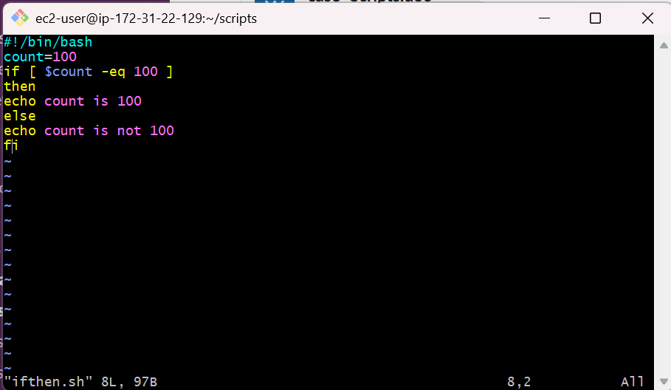

- Then change the permissions with chmod
- Run the command ./ifthen.sh
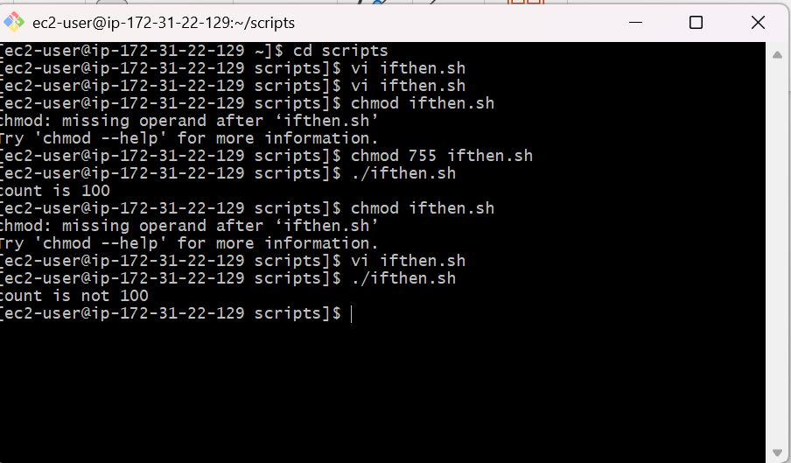
- Case statement scripts:
This will be used when we have multiple options to script.
Example:
Outcome : it will ask to choose one option and will give the answer
Objective : to use multiple options in a script
Step by step manner:
- Create a file case.sh
- Edit the file with the script
- 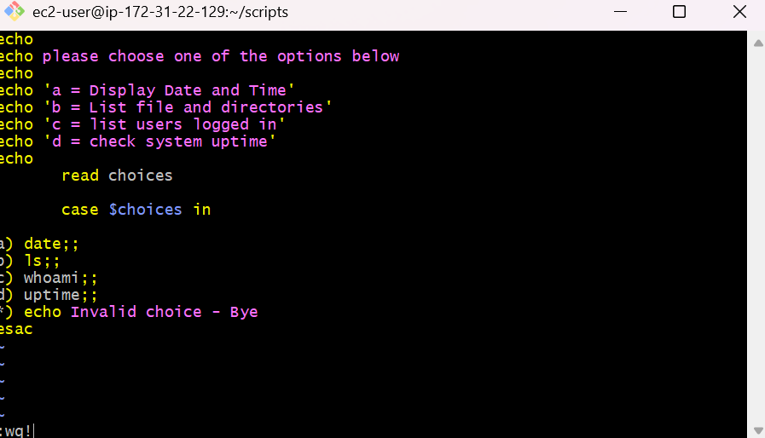
- Change the permissions by the command chmod
- Run the command ./case.sh
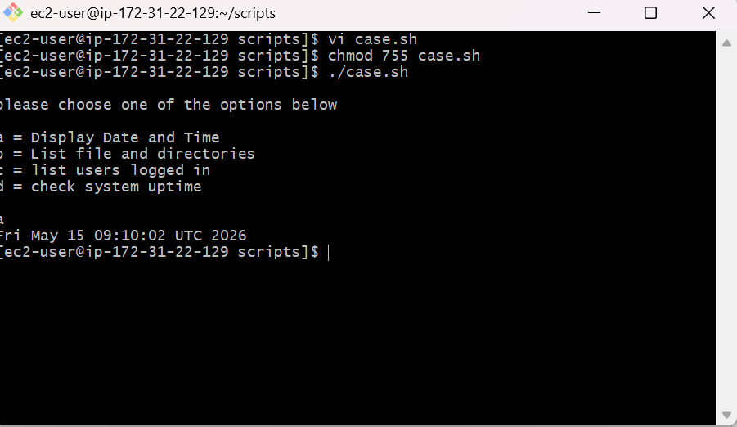

For loop scripts:
- For loop keeps running until specified number of variable
- E.g: variable = 10 then script run for 10 times
- Variable = green, blue, red (then run the script for each color)
Example:
Outcome : it will run the commands for the given times
Objective: to run command in loop
Step by step implementation:
- Create a file -> loop.sh
- Edit the file with desired script
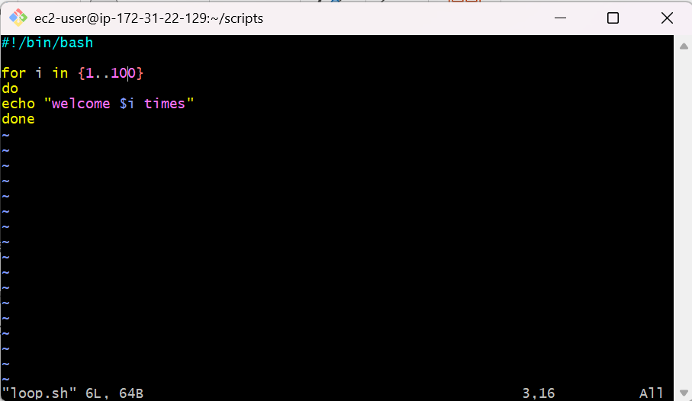

- Then change the permissions by chmod commands
- Run ./loop.sh command to get the output
- 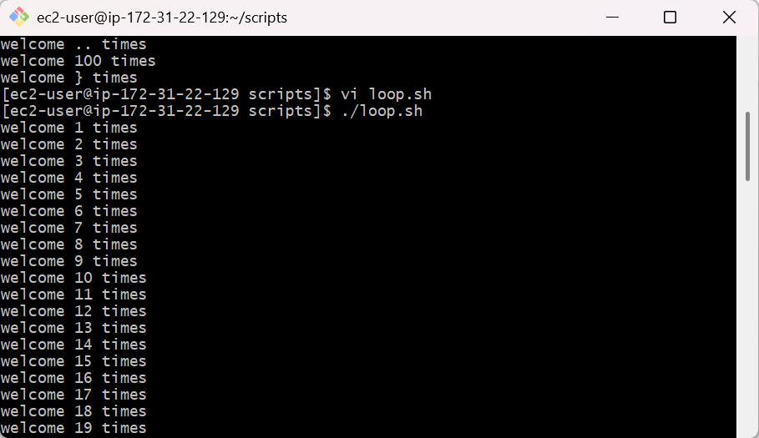
- Do-while scripts:
- This will continuously executed a block of statements while a particular condition is true or met
- Example:
- Outcome: it will print the output for num(variable) times
- Objection: to print output based on do-while condition
- Step by step implementation:
- Create a file dowhile.sh
- Edit the file with script
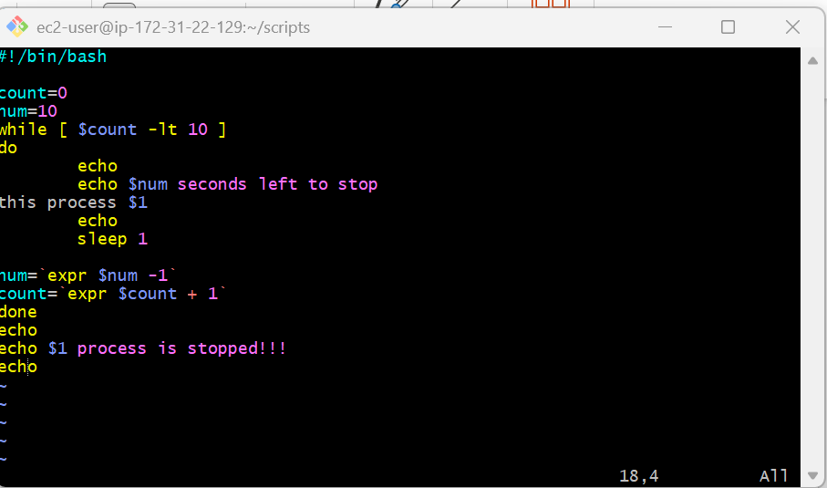

- Change the permissions of the file
- Run the command ./dowhile.sh

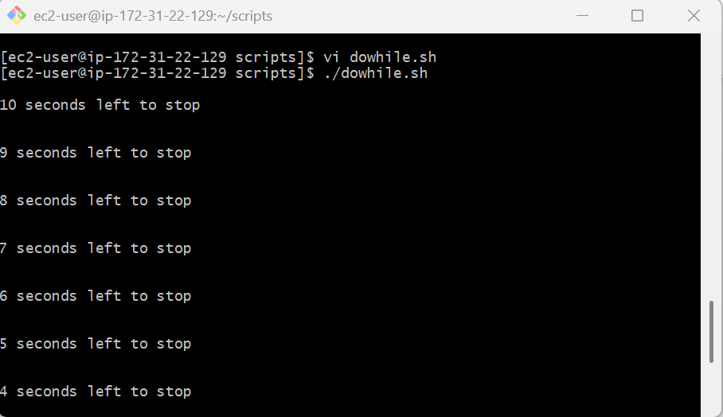

Exit status:
->everytime a command is executed in linux it will have status is associtated with it

*)0 = ok or successful
*)1 = minor problem
*)2 = serious problem
*)3 – 255 = everything else
- To check the exit status of previous execue command -> echo $?
Example:
Outcome : will get the exit status of previous command
Objective : to know the exit status of previous command
Step by step implementation:
- Create a file exit.sh
- Edit the file with script

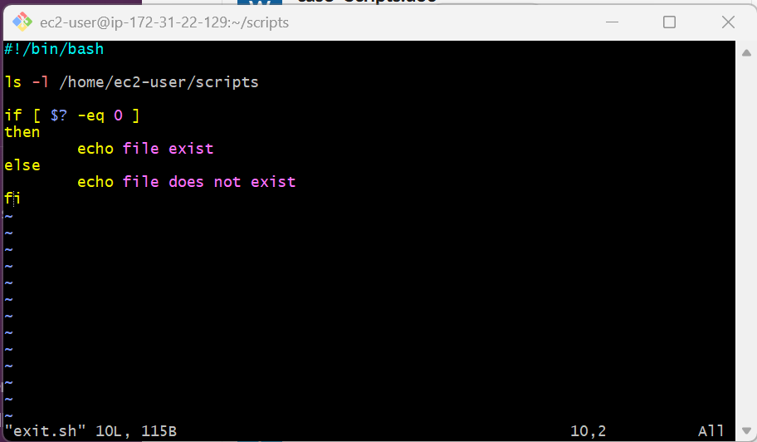

- Change the permissions of the file
- Run the command ./exit.sh to get output

